
Symbiosis Institute of Technology, Pune
Faculty of Engineering
CSE- Academic Year 2026-27
Java Programming – Lab Batch 2024-28
Lab Assignment No:- 13
Name of Student | Aarushi Raizada
PRN No. | 25070122002
Batch | 2025-29
Class | A1
Academic Year & Semester | 2026 Sem III
Date of Submission | 24th August’26
Title of Assignment: | Write a Java program to perform reading from and writing to a file using file handling operations.
Theory  Practice questions | Java provides file handling through the java.io package. Classes such as File, FileReader, FileWriter, BufferedReader, and BufferedWriter are used to perform input and output operations. File handling enables permanent storage and retrieval of application data. Proper exception handling is necessary to manage file-related errors. These concepts are essential for data persistence.  1. Create a program to write and read employee details from a file.  import java.io.*;  public class Employee1 {  public static void main(String[] args) throws IOException {  FileWriter fw = new FileWriter("employee.txt");  fw.write("Employee ID: 101\n");  fw.write("Name: Rahul\n");  fw.write("Salary: 50000\n");  fw.close();  FileReader fr = new FileReader("employee.txt");  int ch;  while ((ch = fr.read()) != -1) {  System.out.print((char) ch);  }  fr.close();  }  }  2. Create a Java program to write patient details (patient ID, name, age, and diagnosis) to a file and read the details from the file for display.  import java.io.*;  public class patient {  public static void main(String[] args) throws IOException {  FileWriter fw = new FileWriter("patient.txt");  fw.write("Patient ID: 101\n");  fw.write("Name: Rahul\n");  fw.write("Age: 25\n");  fw.write("Diagnosis: Fever\n");  fw.close();  FileReader fr = new FileReader("patient.txt");  int ch;  while ((ch = fr.read()) != -1) {  System.out.print((char) ch);  }  fr.close();  }  }
Output Screenshots (if applicable) | Ans 1  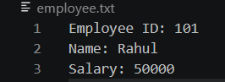  Ans 2  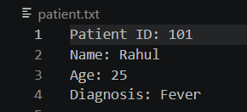
Conclusion | In this experiment, we learnt to perform file reading and writing operations using Java file handling classes.

